SF16Functional Testing:

|  |  |
| --- | --- |
| Your name and group ID: Rovdo Nikolay (453504) | Date: 28-10-2017 |

## Introduction to the project

Imagine that you were assigned to a new project as a tester where domain area – finance. You and your test team lead Victor is located in Minsk. The rest team – in India, China (development) and USA (business analyst, customers and supervisors).

This is a small mobile project developed for Blackberry platform. After login to application you are redirected to the Home screen (please see the screenshot of the Home screen below):

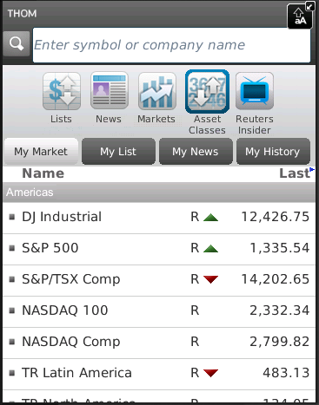

Financial content of the Home screen

Search bar

Main horizontal menu with icons

Customer of the project (named Brian) wants to implement a new feature for this project. Brian was working with business analyst John on requirements for this feature.

So, your task is:

1. Review the requirements for the new feature provided by John.
2. In case of any questions you need to write email to John with request to clarify your questions.
3. Provide estimations for test activities for this feature by email to your test lead Victor.
4. Write test cases for the feature for smoke test.
5. Review provided screens with the implemented feature.
6. Find and submit bugs in case of any.
7. (*optional task) Send test results and your decisions about quality of the feature to Victor.

**Below you will find requirements for the feature and templates for emails, test cases, bug reports and so on, please fill in only those templates that you think reasonable in scope of this feature. Also you can write any additional information that you want.**

## Requirements for the new feature

**User story #045**

**Summary**: As a user I want to access my Profile from the Home screen

**Priority**: Major

**Description**:

* Profile menu icon exists in the Home screen.
* Profile menu icon is positioned on the list of menu icons in the Home screen between Asset Classes and Reuters Insider icons.
* Profile view is displayed when Profile icon is selected.
* The Profile view must have header section (with name, company, location, thought of the day and photo).
* If photo is not available then default image is used.
* The rest of the person’s detail fields can be scrolled, only lines where user has added information are shown.
* Text size must not be too small.

## Clarification letter for business analyst regarding the feature #045:



## Test estimations for the feature #045 to the test team lead Victor:



## Test cases for the feature #045:

|  |  |  |  |  |  |  |
| --- | --- | --- | --- | --- | --- | --- |
| **No** | **Req. No.** | **Module** | **Test Description** | **Expected Results** | **Passed /Failed** | **Comments** |
| **1** | **BBR-1** | **Main** | **1. Open the application**  **2. Login**  **3. Pay attention on icons order on the top** | **User Profile icon exist on header section** | **Passed** |  |
| **No** | **Req. No.** | **Module** | **Test Description** | **Expected Results** | **Passed /Failed** | **Comments** |
| **2** | **BBR-1** | **Main** | **1. Open the application**  **2. Login**  **3. Pay attention on icons order on the top** | **The order of the icons should be List, News, Markets, Asset Classes, Profile, Reuters Insider(From left to right)** | **Failed** |  |
| **No** | **Req. No.** | **Module** | **Test Description** | **Expected Results** | **Passed /Failed** | **Comments** |
| **3** | **BBR-1** | **User Profile** | **1. Open the application**  **2. Login**  **3. Click Profile Icon** | **The Profile view must have header section (with name, company, location, thought of the day).** | **Failed** |  |
| **No** | **Req. No.** | **Module** | **Test Description** | **Expected Results** | **Passed /Failed** | **Comments** |
| **4** | **BBR-1** | **User Profile** | **1. Open the application**  **2. Login**  **3. Click Profile Icon** | **The Profile view must have header section with photo or default photo.** | **Failed** |  |

## The feature #045 is ready for testing:

So, developers have finished implementation the feature #045. You received notification that the build with feature #045 was released and ready for testing. The build was successfully installed. Victor asked you to test the feature. You open the application -> login -> and see the Home screen provided below:

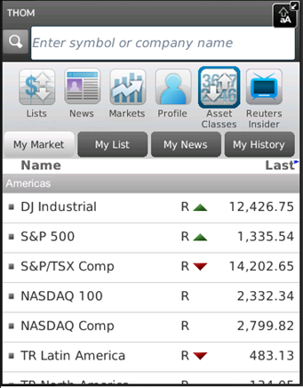

Upon clicking Profile icon in the main horizontal menu the next screen is opened:

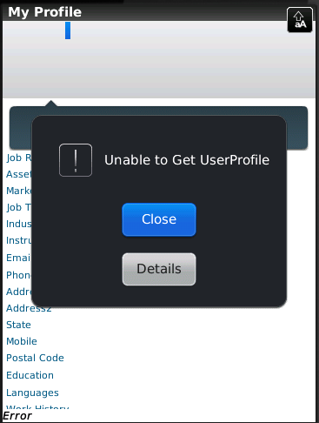

**If you see any bugs in these two screens you can post them below:**

## Templates for bug reports:

|  |  |
| --- | --- |
| **Bug ID** | **#1** |
| **Summary** | **Profile picture does not take correct position** |
| **Description** | **Profile menu icon is positioned on the list of menu icons in the Home screen between Asset Classes and Market icons. The correct position is between Asset Classes and Reuters Insider icons** |
| **Severity** | **Cosmetic** |
| **Steps to reproduce** | 1. **Open the application** 2. **Login** 3. **Pay attention on icons order on the top** |
| **Bug ID** | **#2** |
| **Summary** | **Default image does not appear in user profile tab** |
| **Description** | **If photo is not available then default image should be used. Default user profile picture is not appearing.** |
| **Severity** | **Major** |
| **Steps to reproduce** | 1. **Open the application** 2. **Login** 3. **Click user profile icon** |
| **Bug ID** | **#3** |
| **Summary** | **Application error during opening User Profile** |
| **Description** | **Profile view is displayed when Profile icon is selected. But instead of that Notification Box is appearing with label “Unable to Get UserProfile”** |
| **Severity** | **Critical** |
| **Steps to reproduce** | 1. **Open the application** 2. **Login** 3. **Click user profile icon** |

## Test results to the test team lead:



**Thank you for passing the test and good luck ☺SFT16**